COMSATS University Islamabad

Abbottabad Campus

Assignment No. ___5 _

Student Name: _____Zunair Waqar___________________________
Registration Number: _____________FA22-BCE-037_______________
Class: _______BCE-7A__________________________________

Course: Web Technologies
Instructor: Engr. Engr. Muhammad Naveed Sheikh
Date: __________17 September 2025_______________

Department of Computer Engineering
COMSATS University Islamabad, Abbottabad Campus

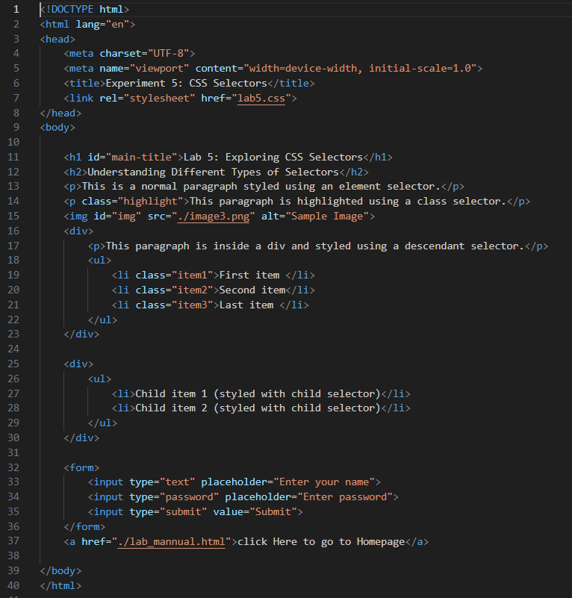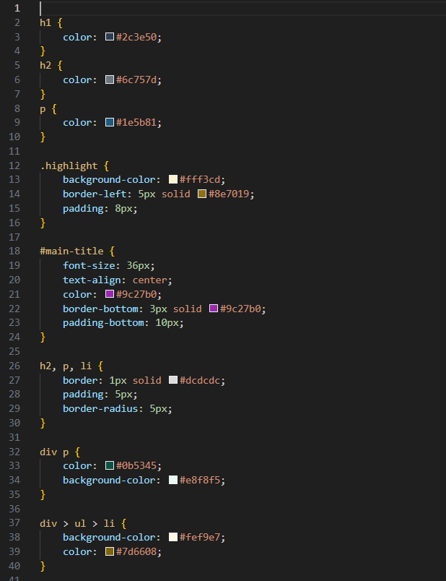

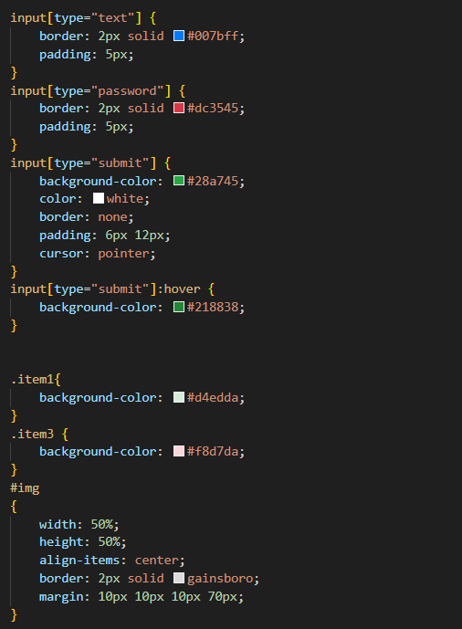
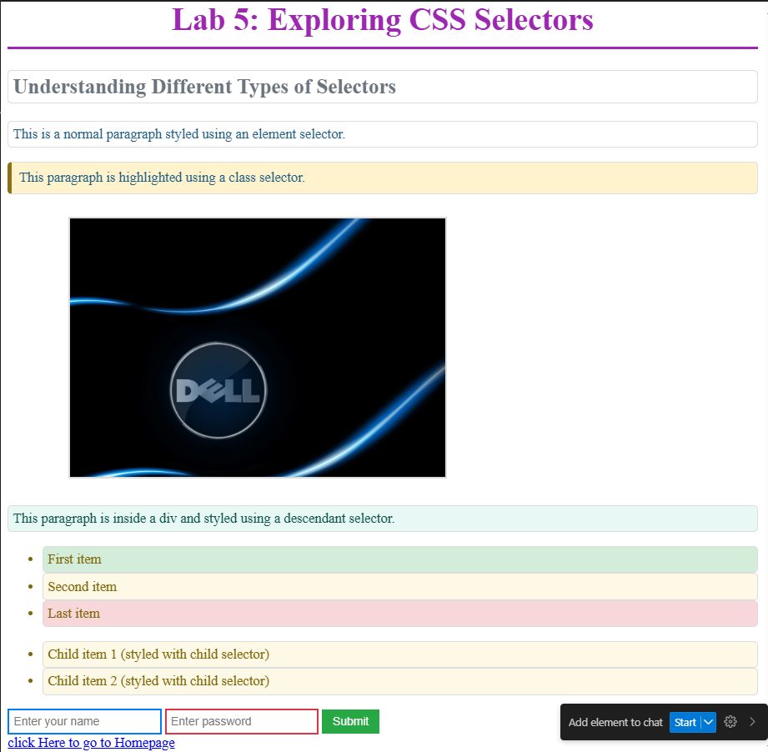
https://zunairwaqar98.github.io/Lab_Mannual/

